INDUSTRIAL TRAINING REPORT

AI Study Companion (Study Genie AI)

Submitted in partial fulfilment of the
Requirements for the award of

Degree of Bachelor of Technology in
Computer Science and Engineering



SUBMITTED BY:

Name: Mohit Kumar
University Roll No: 2224091

SUBMITTED TO: Dr. Brijesh Bakariya
Department of Computer Science & Engineering

IK GUJRAL PUNJAB TECHNICAL UNIVERSITY CAMPUS, HOSHIARPUR

Certificate

DECLARATION

I hereby declare that the Industrial Training Report entitled “AI Study Companion (Study Genie AI)” is an authentic record of my own work as requirements of 6-months Industrial Training during the period from January 2026 to June 2026 for the award of degree of B.Tech. CSE, I. K. Gujral Punjab Technical University Campus, Hoshiarpur, under the guidance of Dr. Brijesh Bakariya

Date: ____________________

Mohit Kumar (2224091)

Certified that the above statement made by the student is correct to the best of our knowledge and belief.

Signatures

Examined by:
1. 2. 3. 4.

Head of Department
(Signature and Seal)
Acknowledgment

Through this acknowledgement, I express our sincere gratitude to all those people who have been associated with this project and have helped me with it and made it a worthwhile experience. Firstly, I would like to thank Director Dr. Vikas Chawla, I.K.G.PTU Campus Hoshiarpur and Dr. Brijesh Bakariya, Head of Department, CSE at I.K.G.PTU Campus, Hoshiarpur for their kind support.

Secondly, I extend my thanks to Er. Gagan Sharma for his immense support as my project guide, as well as the faculty member of O7 Services, for their valuable assistance in completing the project. The atmosphere provided by them fostered knowledge acquisition and enthusiasm. Their assistance in resolving doubts contributed to the project's success within a limited time.

I would also like to thank everyone who has knowingly and unknowingly helped me throughout my work. Last but not least, a word of thanks for the authors of all those books and papers which I have consulted during my project work as well as for preparing the report.

Mohit Kumar (2224091)
B. Tech (CSE) 8th Sem

COMPANY PROFILE



COMPANY NAME: O7 Services
LOCATION: Hoshiarpur
MY PROFILE: Trainee Technology

About Organization
O7 Services is an ISO 9001:2015 Certified company founded in 2015. They specialise in a variety of services including Web Development, Mobile Application Development, AI Bot, Machine learning Algorithm, Data Analytics, Cloud Computing, Cyber Security, Custom Software Development, UI/UX design, Hosting services, Digital Marketing, Registration of Domain Names with various extensions, AMC & MMC Services, Bulk SMS and voice calls. O7 Services offers advanced IT solutions supporting the entire business cycle - from consulting to system development, deployment, quality assurance, and 24x7 support. With over 10 years of experience, the company aims to form long-lasting strategic partnerships with clients, offering affordable prices, timely delivery, and measurable business results. Their headquarters are located in Jalandhar with a branch office in Hoshiarpur.
Some of the products developed by O7 Services include Vehicle Tracking System, Invoice Software, School Management System, Hospital Management System, Parents-Teacher Communication App, Fee Management system, Task Management System, Online Food Ordering App, Security App, Admission system, Inventory Software, and Car Servicing App. Additionally, O7 Services provides training programs including 6 Weeks/6 Months Industrial Training, Project-Based Training, Corporate Training, and Job-Oriented Courses Training, covering major IT trends such as Full Stack Development (MEAN/MERN), Flutter, Kotlin Android, Swift UI (iOS), Firebase, Python, Angular, React Js, Vue Js, Node Js, ASP.NET, .NET Core, PHP, Laravel, CodeIgniter, Software Testing, Cloud Computing, Blockchain, DevOps, Data Science, Artificial Intelligence, Machine Learning, UI/UX Designing, Digital Marketing, WordPress, Linux, CCNP, CCNA Security, Network Security, Cyber Security, MCSE, MCITP, Java, Spring, Hibernate, C/C++, Photoshop, Adobe Illustrator, Figma, CorelDraw and many more.

TABLE OF CONTENTS
Name of Topic | Page No.
CHAPTER 1: INTRODUCTION | 10
1.1 Introduction about project | 10-11
1.2 Objective | 12
1.3 Existing System | 13
1.4 Proposed System | 14
1.5 Project Scope | 15
1.6 Advantages | 16
1.7 Disadvantages | 17
CHAPTER 2: TOOLS & TECHNOLOGY | 18
2.1 Software Requirements | 18-19
2.2 Hardware Requirements | 20-21
2.3 Programming Language Used | 21-22
2.4 Technologies | 22-23
CHAPTER 3: FEASIBILITY STUDY | 24
3.1 Technical Feasibility | 24
3.2 Economic Feasibility | 24
3.3 Operational Feasibility | 25
CHAPTER 4: PROJECT WORK | 26
4.1 Use of pre-trained model in project | 26
4.2 Back-end Technology: FastAPI | 27
4.3 Front-end Technology: Streamlit | 28

CHAPTER 5: DFD DIAGRAM OF AI STUDY COMPANION | 29
5.1 DFD Diagram | 29-33
5.2 DFD Components Working
CHAPTER 6: WORKING | 34
6.1 Project working flowchart
6.2 Project working
CHAPTER 7: WORKING SCREENSHOTS | 35
7.1 Screenshots
CHAPTER 8: CONCLUSION
8.1 Conclusion
CHAPTER 9: REFERENCES
9.1 Conclusion

List of Figures
Figure 1 Level 0 DFD | 29
Figure 2 Level 1 DFD | 30
Figure 3 Level 3 DFD | 33

CHAPTER 1: INTRODUCTION

1.1 Introduction about Project

In today’s fast-paced educational environment, students often struggle to manage vast amounts of academic content effectively. With increasing syllabus complexity, limited time, and a growing reliance on self-study, learners face challenges such as understanding subject material, identifying important topics, and practicing efficiently for examinations. Traditional study methods, which rely heavily on manual note-taking and repetitive reading, are often time-consuming and may not yield optimal results. These challenges highlight the need for intelligent systems that can assist students in organizing, analyzing, and utilizing their study materials in a more effective manner.
The rapid advancement of Artificial Intelligence (AI) and Natural Language Processing (NLP) has opened new opportunities to revolutionize the education sector. AI-powered systems can process large volumes of textual data, extract meaningful insights, and provide personalized learning experiences. Leveraging these technologies, the proposed project, AI Study Companion (Study Genie AI), aims to assist students in enhancing their learning efficiency by transforming raw study materials into structured and actionable knowledge.
The primary objective of Study Genie AI is to simplify the study process by automatically analyzing educational content such as notes, syllabus documents, and previous year question papers (PYQs). Students often find it difficult to determine which topics are most important or frequently asked in exams. By applying AI techniques, the system can identify patterns in the provided data and highlight key areas that require more attention. This enables students to focus their efforts strategically rather than studying everything uniformly.
The working of the system involves multiple stages. First, the user uploads relevant study materials, including notes, syllabus, and PYQs. These inputs may be in the form of text or documents such as PDFs. Once uploaded, the AI system processes the textual data using NLP techniques such as tokenization, keyword extraction, and semantic analysis. The system then extracts patterns, such as frequently occurring topics, important keywords, and question trends from previous examinations. These insights form the foundation for generating useful study resources.
Based on the processed data, Study Genie AI generates several outputs designed to improve learning outcomes. It creates quizzes that help students test their understanding of key concepts, flashcards for quick revision, and a list of important topics based on analysis of the syllabus and past questions. Additionally, the system provides a personalized study plan, enabling students to allocate time effectively and cover the syllabus in a structured manner. These features collectively support active learning and better retention of information.
One of the key advantages of this system is its ability to automate repetitive and time-intensive tasks. Instead of manually reviewing large amounts of study material, students can rely on the AI system to extract relevant information quickly and accurately. Furthermore, the system can adapt to different subjects and user inputs, making it a versatile tool for a wide range of academic needs.

1.2 Objectives
- The primary objective of the AI Study Companion (Study Genie AI) is to enhance the learning experience of students by leveraging Artificial Intelligence (AI) and Natural Language Processing (NLP) techniques. The system is designed to simplify the study process, improve productivity, and enable students to focus on important concepts rather than spending excessive time organizing and analyzing study materials.

- One of the key objectives of this project is to develop an intelligent system capable of processing diverse educational inputs such as notes, syllabus documents, and previous year question papers (PYQs). These inputs often exist in unstructured formats,

- making it difficult for students to extract meaningful information. The system aims to convert this unstructured data into structured and useful outputs that can support effective learning.

- Another important objective is to identify and highlight important topics from the given study materials. Students frequently face challenges in determining which topics carry more weight in examinations. By analyzing patterns in the syllabus and PYQs, the system aims to predict frequently asked questions and key concepts, allowing students to prioritize their preparation accordingly.

- The project also aims to automate the generation of study resources such as quizzes and flashcards. These tools are essential for active learning and self-assessment. By generating quizzes, the system helps students evaluate their understanding of different topics, while flashcards assist in quick revision and memory retention. This reduces the need for manual creation of such resources and saves valuable time.

1.3 Existing System:
The current methods used by students for studying and exam preparation are mostly traditional and lack the support of intelligent automation. These existing systems present several limitations that affect learning efficiency and productivity. The following are the key drawbacks of the existing system:
- Manual Study Process:
Most students rely on manual methods such as reading textbooks, making handwritten notes, and highlighting important points. This process is time-consuming and often inefficient, as students have to individually analyze large volumes of content without any automated assistance.

- Lack of Centralized Study Material:
Study resources such as notes, syllabus, and previous year question papers (PYQs) are usually scattered across different platforms or stored in physical form. This makes it difficult for students to organize and access all relevant materials in one place, leading to confusion and wasted time.

- Difficulty in Identifying Important Topics:
Students often struggle to determine which topics are most important for exams. Without proper analysis tools, they may spend equal time on all topics instead of focusing on high-weightage or frequently asked concepts.

- Limited Accessibility and Flexibility:
Traditional study methods are not always accessible anytime and anywhere. Physical notes or offline materials restrict flexibility, especially when students need quick access to information or revision materials on the go.

1.4 Proposed System:
The proposed system, AI Study Companion (Study Genie AI), is designed to overcome the limitations of traditional study methods by integrating Artificial Intelligence (AI) and Natural Language Processing (NLP). It provides an intelligent, automated, and user-friendly platform that helps students manage their study materials, identify important topics, and enhance their overall learning experience. The key components of the proposed system are as follows:

- User Management:
The system will implement secure user authentication and authorization mechanisms to manage different types of users, such as students and administrators. Each user will have personalized access to features like uploading study materials, viewing generated content, and tracking their progress. This ensures data privacy and a customized learning experience.

- Study Material Management:
The system will allow users to upload, edit, and manage various study resources such as notes, syllabus documents, and previous year question papers (PYQs). It will support multiple formats like text and PDF, and store all data in a centralized database for easy access and organization.

- Study Planning and Scheduling:
Users will be able to generate personalized study plans based on their syllabus, available time, and identified important topics. The system can also provide scheduling features and reminders to help students stay consistent with their study routines.

- Content Processing and Analysis:
The core functionality of the system lies in processing uploaded data using NLP techniques. It will analyze the content to extract keywords, identify patterns, and determine frequently asked topics from PYQs. This helps in prioritizing study areas and improving exam preparation strategies.

1.5 Project Scope:
The scope of the AI Study Companion (Study Genie AI) project is to develop an intelligent and efficient platform that assists students in managing and improving their study process. The system is designed to handle various types of academic inputs such as notes, syllabus, and previous year question papers, and transform them into meaningful and structured learning resources. By integrating Artificial Intelligence and Natural Language Processing techniques, the project aims to automate tasks like content analysis, topic identification, and study material generation. It also focuses on providing personalized study plans and performance insights, making learning more organized and effective. Overall, the project scope covers the development of a user-friendly, accessible, and scalable solution that enhances students’ productivity and supports smarter learning.

- Automated Analysis of Study Materials:
The system focuses on analyzing user-uploaded content such as notes, syllabus, and previous year question papers (PYQs). By using AI and NLP techniques, it extracts key information, identifies important topics, and detects patterns to support effective learning.

- Generation of Smart Learning Resources:
The project includes automatic generation of quizzes, flashcards, and important topic lists. These resources help students in self-assessment, quick revision, and improving concept clarity without manual effort.

- Personalized Study Planning:
The system provides customized study plans based on the analyzed data and user requirements. It helps students prioritize topics, manage time efficiently, and follow a structured approach to complete their syllabus.

- Performance Tracking and Insights:
The system tracks user progress through quizzes and study activities. It provides insights such as strengths, weaknesses, and topic-wise performance, helping students improve their preparation strategy.

1.6 Advantages:
- Saves Time and Effort:
The system significantly reduces the manual effort required in traditional studying methods. Instead of spending hours reading and analyzing notes, students can upload their study materials and let the system automatically process the content. It identifies key topics, generates summaries, and creates quizzes or flashcards within seconds. This automation allows students to focus more on understanding concepts rather than organizing and filtering information.

- Improves Learning Efficiency:
One of the major benefits of the system is its ability to highlight important and high-priority topics based on syllabus analysis and previous year question papers. This helps students avoid unnecessary topics and concentrate on areas that are more likely to appear in exams. As a result, students can utilize their study time more effectively and achieve better academic performance with less effort.

- Personalized Study Experience:
Every student has a different learning style, pace, and schedule. The system takes this into account by generating personalized study plans tailored to individual needs. It can adjust recommendations based on the user’s progress and performance, ensuring that weak areas are given more attention. This personalized approach enhances understanding and makes learning more comfortable and effective.

- Enhances Revision and Practice:
The project supports active learning by providing automatically generated quizzes and flashcards. These tools help students regularly test their knowledge and reinforce important concepts. Flashcards are particularly useful for quick revision, while quizzes help in self-assessment and identifying knowledge gaps. This continuous practice improves memory retention and boosts confidence before exams.

1.7 Disadvantages:
- Dependence and Input Quality:
The accuracy of the system’s output highly depends on the quality of the uploaded study materials. If the notes, syllabus, or PYQs are incomplete, unclear, or poorly structured, the generated results such as quizzes or important topics may not be fully reliable.

- Limited Understanding of Complex Context:
Although AI and NLP are powerful, the system may sometimes fail to fully understand complex concepts, deep theoretical content, or context-specific meanings. This can affect the accuracy of topic extraction and content generation.

- Internet Dependency:
Since the system is designed as a web-based platform, it requires a stable internet connection for uploading data, processing content, and accessing generated resources. This may limit usability in areas with poor connectivity.

- Lack of Human-Level Personalization:
While the system provides personalized study plans, it may not match the level of customization offered by a human teacher or mentor. It cannot fully understand individual emotions, learning difficulties, or unique study preferences.

- Initial Setup and Learning Curve:
New users may require some time to understand how to use the platform effectively, such as uploading proper materials or interpreting the generated outputs. This may create a slight learning curve at the beginning.

CHAPTER 2: TOOLS & TECHNOLOGY

2.1 SOFTWARE REQUIREMENTS: -
- Operating System
The system can be developed and deployed on multiple operating systems, including:
- Windows 10 / 11
- Linux (Ubuntu recommended)
- macOS
These platforms provide compatibility with development tools and AI frameworks.
- Web Browser
To access the application, users require a modern web browser such as:
- Google Chrome
- Mozilla Firefox
- Microsoft Edge
These browsers ensure proper rendering of the user interface and smooth interaction with the system.
- Front-End Technology
- Streamlit:
Used to build an interactive and user-friendly web interface. It allows easy integration with Python-based backend and enables quick visualization of results such as quizzes, flashcards, and analytics.
- Back-End Technology
- Python:
The core programming language used for developing the application logic.
- FastAPI:
Used for building scalable APIs and handling backend requests efficiently. It helps in connecting the front-end with AI models and processing user inputs.
- 5 AI & Machine Learning Technologies
- Natural Language Processing (NLP):
Used for analyzing text data, extracting keywords, identifying patterns, and generating summaries.
- Libraries and Frameworks:
  - NLTK (Natural Language Toolkit)
  - spaCy
  - Transformers (Hugging Face)
These tools help in text processing, tokenization, and implementing pre-trained models.
- Pre-trained Models
- Hugging Face models for:
  - Text summarization
  - Question generation
  - Keyword extraction
These models reduce development time and improve system performance.
- Database
- SQLite / MongoDB (optional):
Used for storing user data, study materials, generated quizzes, and progress tracking.
- Development Tools
- Visual Studio Code (VS Code) or PyCharm
- Jupyter Notebook (for model experimentation)
These tools assist in coding, debugging, and testing the system.

2.2 HARDWARE REQUIREMENTS: -
  - Processor (CPU)
- Minimum: Intel Core i3 or equivalent
- Recommended: Intel Core i5 / i7 or AMD Ryzen 5 and above
A higher-performance processor ensures faster data processing and smooth execution of AI tasks.
- Memory (RAM)
- Minimum: 4 GB
- Recommended: 8 GB or higher
Adequate RAM is required for handling multiple processes, especially while working with NLP libraries and large text data.
- Storage
- Minimum: 20 GB free disk space
- Recommended: 50 GB or more (SSD preferred)
Sufficient storage is needed for saving datasets, study materials, AI models, and application files. SSD improves speed and performance.
- Graphics (GPU) (Optional)
- Not mandatory for basic functionality
- Recommended: NVIDIA GPU (for advanced AI model training)
A GPU can significantly speed up training and processing of large AI models, though it is optional for this project.
- Input Devices
- Keyboard and Mouse
Required for user interaction, development, and navigation within the system.

- Output Devices
- Monitor/Display Screen
Used to view the application interface, generated outputs, and analytics.
- Internet Connectivity
- Required for accessing web-based features, downloading libraries, and using pre-trained models
2.3 Programming Language used
The development of the AI Study Companion (StudyGenie AI) is primarily based on the Python programming language, which is widely recognized as one of the most suitable languages for Artificial Intelligence (AI) and Machine Learning (ML) applications. Python has gained immense popularity in recent years due to its simple syntax, readability, and extensive support for libraries and frameworks. These features make it highly efficient for both beginners and experienced developers.
In this project, Python serves as the backbone of the entire system. It is used to implement the core functionalities, including data processing, backend development, and integration of AI models. One of the major reasons for selecting Python is its rich ecosystem of libraries that support Natural Language Processing (NLP), such as NLTK and spaCy. These libraries enable the system to perform tasks like text preprocessing, tokenization, stop word removal, and keyword extraction, which are essential for analyzing study materials.
Another important aspect of Python is its ability to handle unstructured data efficiently. Since the project deals with textual data from notes, syllabus documents, and previous year question papers (PYQs), Python provides the necessary tools to process and analyze such data effectively. It also allows easy integration with pre-trained models from platforms like Hugging Face, which significantly enhances the system’s capability without requiring complex model training.
Python also plays a key role in backend development through frameworks like FastAPI, which allows smooth handling of user requests and communication between different components of the system. Furthermore, Python integrates seamlessly with frontend technologies like Streamlit, enabling developers to build complete end-to-end applications using a single programming language.
In addition to its technical capabilities, Python supports rapid development and prototyping. This is particularly useful in academic projects, where time constraints require efficient development cycles. Debugging and maintaining Python code is also easier due to its clear structure and large community support.
Overall, Python provides a flexible, scalable, and efficient environment for developing the AI Study Companion. Its versatility and strong support for AI technologies make it the most appropriate choice for implementing this project.
2.4 Technologies
The AI Study Companion (StudyGenie AI) integrates a variety of modern technologies to create an intelligent and interactive learning platform. These technologies are carefully selected to ensure efficient data processing, smooth user interaction, and accurate generation of study resources. The system combines frontend, backend, and AI technologies to deliver a complete solution.
For the frontend development, the project uses Streamlit, an open-source Python framework designed for building interactive web applications. Streamlit provides a simple and intuitive interface that allows users to upload study materials such as notes, syllabus, and PYQs. It also displays outputs like quizzes, flashcards, and study plans in a clear and organized manner. One of the key advantages of Streamlit is its ability to update results in real time, which enhances user experience. Additionally, it reduces the need for complex frontend technologies like HTML, CSS, and JavaScript, making development faster and more efficient.
The backend of the system is developed using FastAPI, a modern and high-performance web framework for building APIs. FastAPI handles the core logic of the application, including processing user inputs, managing data flow, and interacting with AI models. When a user uploads a document, the request is sent to the FastAPI server, where the data is processed using NLP techniques. The results are then returned to the frontend for display. FastAPI supports asynchronous programming, which allows the system to handle multiple requests simultaneously, ensuring high performance and responsiveness.
In terms of Artificial Intelligence and Natural Language Processing, the project uses libraries such as NLTK and spaCy. These libraries provide tools for analyzing and processing textual data. They are used for tasks such as tokenization, stop word removal, part-of-speech tagging, and keyword extraction. These processes help in converting unstructured text into a structured format that can be analyzed effectively.
A key component of the project is the use of pre-trained models from Hugging Face, particularly the sentence-transformer/all-MiniLM-L6-v2 model. This model generates sentence embeddings that capture the semantic meaning of text. It enables the system to identify similarities between different pieces of content, match related topics, and improve the accuracy of analysis. The use of pre-trained models reduces development time and enhances system performance.
For data extraction and processing, libraries such as PyPDF2 or pdfplumber are used to extract text from PDF files uploaded by users. Additionally, Pandas and NumPy are used for data manipulation and organization, ensuring efficient handling of large volumes of text data.
The system may also include a database such as SQLite or MongoDB for storing user data, uploaded files, and generated outputs. This helps in maintaining records and allows users to access their data in future sessions.
To support development, tools such as Visual Studio Code (VS Code) and Jupyter Notebook are used. VS Code provides a powerful environment for coding and debugging, while Jupyter Notebook is useful for experimenting with AI models and data analysis.
Overall, the combination of these technologies creates a robust, scalable, and efficient system. Each technology plays a specific role in the development process, and together they enable the AI Study Companion to deliver intelligent and user-friendly learning solutions.

CHAPTER 3: FEASIBILITY STUDY
The feasibility study evaluates the practicality and viability of developing the AI Study Companion (StudyGenie AI) system. It analyzes different aspects such as technical, economic, operational, and schedule feasibility to determine whether the project can be successfully implemented. it focuses on following:
- Meet user requirements
- Best utilization of available resources
- Develop a cost-effective system
- Develop a technically feasible system
It is further classified into 3 aspects:
3.1 Technical Feasibility:
Technical feasibility evaluates whether the required technology and resources are available to develop the system. In the case of StudyGenie AI, the project is technically feasible because it uses well-established technologies such as Python, Streamlit, FastAPI, and NLP libraries like NLTK and spaCy. The integration of pre-trained models from platforms like Hugging Face further simplifies development, as there is no need to build complex models from scratch. Additionally, the system can run on standard computing devices without requiring high-end infrastructure. The availability of extensive documentation and community support also makes it easier to implement and troubleshoot the system effectively.
3.2 Economic Feasibility:
Economic feasibility focuses on the cost-effectiveness of the project. The StudyGenie AI project is economically feasible as it relies mainly on open-source tools and frameworks, which significantly reduces development costs. There is no need for expensive software licenses or specialized hardware for basic implementation. Most of the development can be carried out using a personal computer with internet access. Optional costs may arise if the system is deployed on cloud platforms, but even those can be managed with low-cost or free-tier services. Overall, the project offers a high benefit-to-cost ratio, making it suitable for academic and small-scale applications.
3.3 Operational Feasibility:
Operational feasibility examines how well the system will function in a real-world environment and whether it will be accepted by users. The StudyGenie AI system is designed to be simple, user-friendly, and accessible, ensuring that students can easily interact with it without requiring technical expertise. The interface allows users to upload study materials and receive outputs such as quizzes, flashcards, and study plans in an intuitive manner. The system addresses real problems faced by students, making it highly useful and practical. Therefore, it is expected to have a high level of user acceptance and usability.

CHAPTER 4: PROJECT WORK
4.1 Use of Pre-trained Model in Project Work:
In the development of the AI Study Companion (StudyGenie AI), a pre-trained model named sentence-transformer/all-MiniLM-L6-v2 has been utilized to enhance the system’s Natural Language Processing capabilities. This model is obtained from the Hugging Face library and is specifically designed for generating high-quality sentence embeddings.
The sentence-transformer/all-MiniLM-L6-v2 model is a lightweight and efficient transformer-based model that converts textual data into numerical vector representations, also known as embeddings. These embeddings capture the semantic meaning of the text, allowing the system to understand the context and similarity between different pieces of content. This is particularly useful in analyzing study materials such as notes, syllabus, and previous year question papers (PYQs).
In this project, the model plays a crucial role in multiple tasks. It is used to measure semantic similarity between different topics, identify related concepts, and group similar content together. For example, when a student upload notes and PYQs, the model helps in matching similar questions and topics, enabling the system to identify frequently asked concepts and important areas for study. This improves the accuracy of topic extraction and ensures that the generated outputs are relevant and meaningful.
Additionally, the model supports efficient search and retrieval operations within the system. By converting text into embeddings, the system can quickly compare and rank content based on similarity scores. This allows users to find relevant information from their uploaded materials without manually searching through large volumes of text.
One of the major advantages of using this model is its balance between performance and computational efficiency. It provides high-quality semantic understanding while being lightweight enough to run on standard hardware without requiring high-end GPUs. This makes it suitable for real-time applications like StudyGenie AI, where quick response time is important.
Furthermore, integrating this pre-trained model reduces the need for training a model from scratch, saving both time and computational resources. It also ensures reliability, as the model has already been trained on large-scale datasets and optimized for general-purpose language understanding tasks.
In conclusion, the use of the sentence-transformer/all-MiniLM-L6-v2 model significantly enhances the system’s ability to process and analyze textual data. It enables accurate topic identification, efficient content matching, and improved generation of learning resources, thereby contributing to the overall effectiveness of the AI Study Companion.
4.2 Backend Technology: FastAPI
In the development of the AI Study Companion (StudyGenie AI), the backend is implemented using FastAPI, a modern and high-performance web framework for building APIs with Python. FastAPI is widely used for developing scalable and efficient backend systems due to its speed, simplicity, and support for asynchronous programming.
FastAPI plays a crucial role in handling the core functionality of the system. It acts as a bridge between the front-end interface and the AI models used for processing study materials. When a user uploads notes, syllabus, or previous year question papers (PYQs), the request is sent to the FastAPI backend, where the data is processed using NLP techniques and AI models. The backend performs tasks such as text extraction, preprocessing, semantic analysis, and generation of outputs like quizzes, flashcards, and important topics.
One of the key advantages of FastAPI is its ability to create RESTful APIs quickly and efficiently. These APIs enable smooth communication between different components of the system. FastAPI also provides automatic API documentation using Swagger UI, which simplifies testing and debugging during development.
Another important feature of FastAPI is its high performance, which is comparable to Node.js and Go-based frameworks. It uses asynchronous programming (async/await), allowing multiple requests to be handled simultaneously without slowing down the system. This is particularly beneficial for AI-based applications where processing time can vary depending on the complexity of input data.
Additionally, FastAPI ensures data validation using Python type hints, reducing errors and improving code reliability. It also supports easy integration with machine learning libraries and databases, making it an ideal choice for building intelligent applications like StudyGenie AI.
4.3 Front-end Technology: Streamlit
The front-end of the AI Study Companion (StudyGenie AI) is developed using Streamlit, an open-source Python framework used for building interactive and user-friendly web applications. Streamlit is especially suitable for AI and data science projects because it allows developers to create web interfaces quickly without requiring extensive knowledge of HTML, CSS, or JavaScript.
Streamlit is responsible for providing an intuitive interface through which users can interact with the system. It allows students to upload study materials such as notes, syllabus, and PYQs, and view the generated outputs including quizzes, flashcards, important topics, and study plans. The interface is designed to be simple, clean, and easy to navigate, ensuring a smooth user experience.
One of the major advantages of Streamlit is its ability to display results in real-time. As soon as the backend processes the data, the results are instantly reflected on the front-end interface. Streamlit also supports various UI components such as file uploaders, buttons, text boxes, and charts, which enhance interactivity and usability.
Another key feature of Streamlit is its rapid development capability. Developers can build and modify the user interface with minimal code, making it ideal for prototyping and iterative development. It also integrates seamlessly with Python-based backend systems like FastAPI and supports visualization libraries for displaying analytics and insights.
Furthermore, Streamlit applications are easily deployable and accessible through web browsers, allowing users to access the system from different devices without installation. This makes the application flexible and convenient for students.
Together, FastAPI (backend) and Streamlit (frontend) create a powerful and efficient architecture for the AI Study Companion, ensuring smooth data processing, fast performance, and an interactive user experience.
CHAPTER 5: DFD DIAGRAM OF PROJECT
5.1 DFD Diagram:
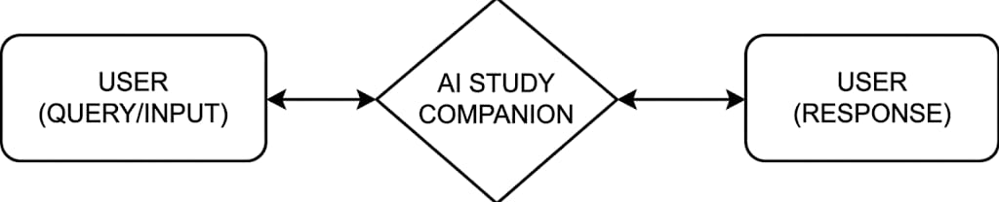
Figure 1 Level 0 DFD
At the highest level, the level 0 DFD provides an overview of the major processes or subsystems involved in the AI Study Companion project. It typically includes three main processes:
- USER(QUERY/INPUT): This entity represents the user (student) who interacts with the system. The user provides input in the form of:
- Notes
- Syllabus
- Previous Year Question Papers (PYQs)
- Queries or study-related requests
These inputs are sent to the AI Study Companion system for processing.

- AI STUDY COMPANION: This is the main processing unit of the system, represented by the central diamond shape. It performs all the core operations of the project.
The system processes the input data using:
- Natural Language Processing (NLP)
- AI models (like sentence-transformers)
- Text analysis techniques
The main functions performed include:
- Extracting important topics
- Identifying patterns from PYQs
- Generating quizzes and flashcards
- Creating personalized study plans
This process transforms raw input data into meaningful and useful outputs.

- USER(RESPONSE): After processing the input, the system generates output and sends it back to the user. The outputs include:
- Quiz questions
- Flashcards
- Important topics
- Study plans
This helps the user in better understanding, revision, and exam preparation
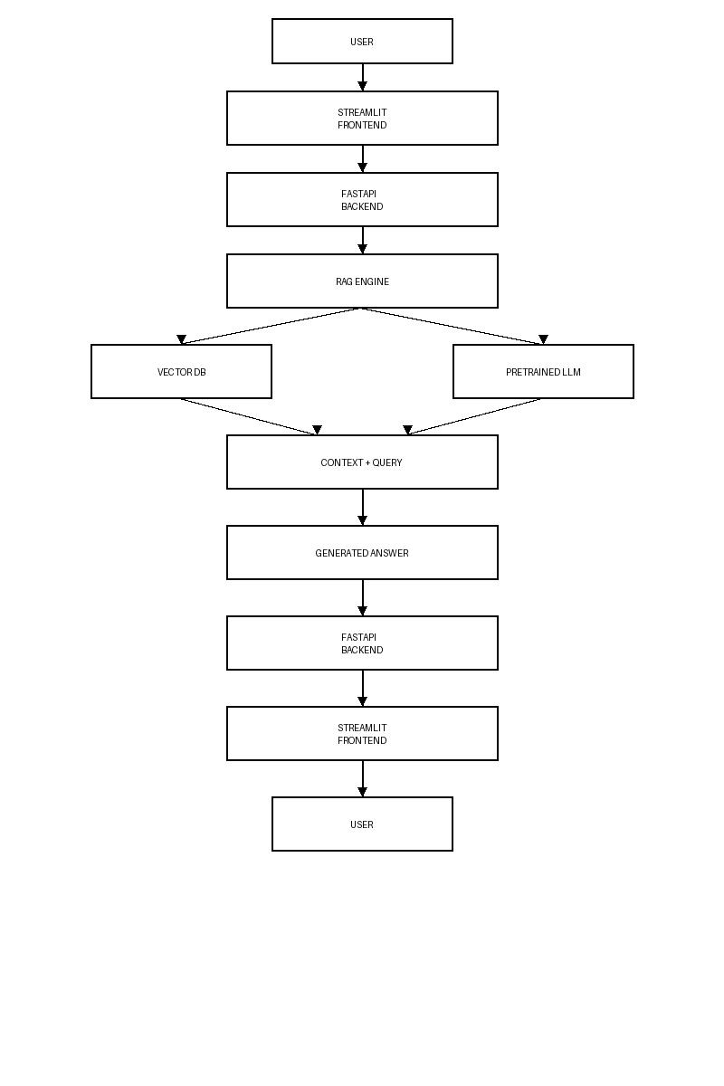

Figure 2 Level 1 DFD
The level 1 DFD provides a more detailed breakdown of each of the major processes identified in level 0 DFD. For example:
- User Input: The process begins with the user, who interacts with the system by providing input in the form of:
- Study notes
- Syllabus
- Previous year question papers (PYQs)
- Queries or questions
This input acts as the primary data source for the system.
- Streamlit Frontend: The input provided by the user is received through the Streamlit frontend, which acts as the user interface. It allows users to:
- Upload files
- Enter queries
- View generated outputs
The frontend ensures smooth interaction between the user and the system.

- FastAPI Backend: The data from the frontend is sent to the FastAPI backend. This component handles:
- Request processing
- Data validation
- Communication with AI modules
It acts as a bridge between the user interface and the core processing system.

- RAG Engine (Core Processing Unit): The RAG (Retrieval-Augmented Generation) Engine is the central component of the system. It is responsible for:
- Processing user queries
- Retrieving relevant information
- Enhancing AI-generated responses with contextual data
This component ensures that the output is both accurate and context-aware.

- Vector Database: The RAG engine interacts with the Vector Database, which stores embeddings of study materials. It is used to:
- Perform similarity search
- Retrieve relevant content
- Match user queries with stored knowledge
This helps in improving the relevance of the generated output.
- Pre-trained LLM (AI Model): The system also interacts with a pre-trained Large Language Model (LLM). This model:
- Understands the query
- Generates human-like responses
- Uses context provided by the RAG engine
It is responsible for producing intelligent and meaningful answers.

- Context + Query Formation: The retrieved data from the vector database and the user query are combined to form a context-rich input. This step ensures:
- Better understanding of the query
- More accurate and relevant responses

- Generated Answer: The AI model processes the combined input and generates:
- Quiz questions
- Flashcards
- Important topics
- Study plans
- Answers to user queries

- Response via Backend and Frontend: The generated answer is sent back through:
- FastAPI backend (processing response)
- Streamlit frontend (displaying output)

- Final Output to User: Finally, the processed output is displayed to the user, completing the system cycle. The user can then use this information for study and revision.

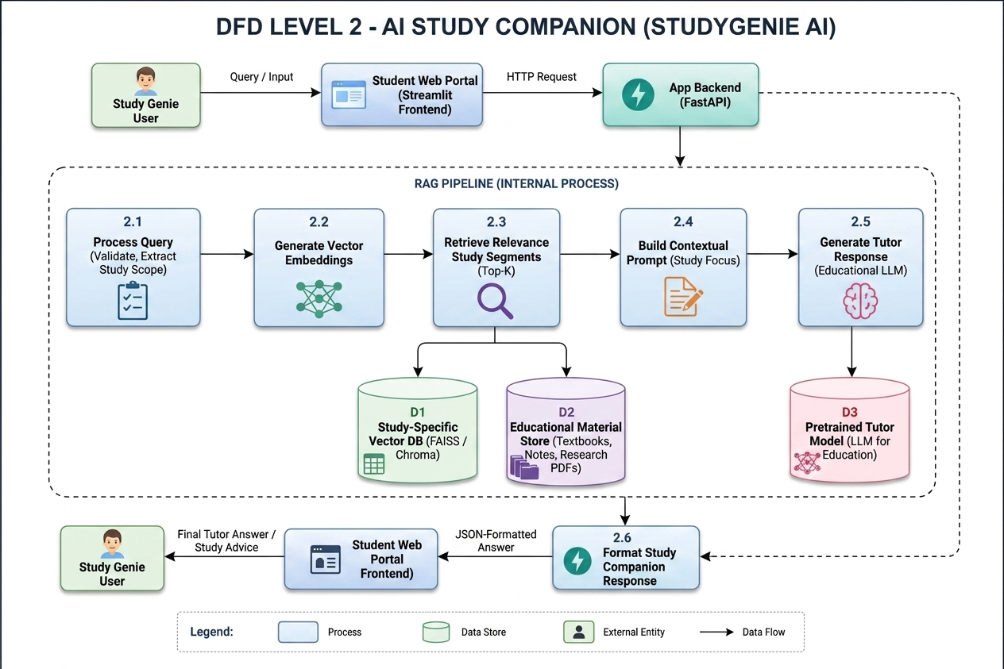
Figure 3 Level 2 DFD

CHAPTER 6: WORKING

CHAPTER 7: WORKING SCREENSHOTS

CHAPTER 8: CONCLUSION
The AI Study Companion (StudyGenie AI) project represents a significant step toward integrating modern technologies such as Artificial Intelligence (AI) and Natural Language Processing (NLP) into the field of education. In an era where students are required to manage large volumes of academic content within limited time, this system provides an intelligent and efficient solution to simplify the learning process. The project successfully addresses key challenges faced by students, including understanding the syllabus, identifying important topics, and practicing effectively.
Throughout the development of this project, various technologies and methodologies were implemented to create a robust and user-friendly system. The integration of NLP techniques enables the system to process and analyze unstructured textual data from notes, syllabus documents, and previous year question papers (PYQs). By extracting meaningful patterns and insights, the system helps students focus on relevant and high-priority topics. The use of pre-trained models, such as sentence-transformers, enhances the system’s ability to understand semantic relationships between different pieces of content, thereby improving the accuracy of results.
The project also demonstrates the effective use of modern web technologies. The backend, developed using FastAPI, ensures efficient handling of data processing and communication between system components. The frontend, built using Streamlit, provides a simple and interactive interface that allows users to easily upload study materials and access generated outputs. This combination of technologies results in a seamless and responsive user experience.
One of the major achievements of the project is the automation of study resource generation. The system is capable of generating quizzes, flashcards, and lists of important topics, which are essential tools for active learning and revision. Additionally, the personalized study plan feature helps students organize their preparation in a structured manner, improving time management and overall productivity. These features collectively contribute to a smarter and more effective approach to learning.
The project also emphasizes accessibility and convenience. By developing the system as a web-based application, users can access their study materials and generated resources anytime and from any device. This flexibility is particularly beneficial for students who require quick access to information during revision or exam preparation.
Despite its advantages, the project also has certain limitations, such as dependency on the quality of input data and the inherent challenges of accurately understanding complex textual content. However, these limitations provide opportunities for future improvements and enhancements. With further advancements in AI and the incorporation of more sophisticated models, the system can be made even more accurate and capable.
In conclusion, the AI Study Companion (StudyGenie AI) successfully demonstrates how AI-driven solutions can transform traditional study methods into a more efficient and personalized learning experience. The project not only reduces the burden of manual study processes but also empowers students to make data-driven decisions in their preparation. It highlights the potential of AI in education and sets a foundation for developing more advanced intelligent learning systems in the future.
Overall, this project achieves its objectives by providing an innovative, scalable, and practical solution that enhances the quality of learning. It serves as a valuable tool for students and a promising example of how technology can be leveraged to improve educational outcomes in the digital age.
The combination of modern tools and technologies used in the AI Study Companion (StudyGenie AI) ensures the development of a powerful and efficient system. Python, Streamlit, FastAPI, and NLP models work together to create an intelligent platform that enhances the learning experience of students. The selected technologies not only support the current functionality but also provide flexibility for future enhancements and scalability.

CHAPTER 9: REFERENCES

